Dear Parents/Guardians,
As access to the school is prohibited by the HSE and CPSMA, please find below some instructions and guidelines on how to access school books. These are available online for your children at their class level should you wish to explore this option.

Folens have some excellent online resources including copies of the children’s books we use in school. These can be accessed on their website.
Please follow the link to register for access to these resources/books: https://www.folensonline.ie/registration/
- Select Teacher
- Fill in a username, email and password
- For the roll number use: Prim20
Once you are logged in you can search the book that you are looking for in the search bar.
If you go through the library and click the star in the top right hand side, this will then favourite the book. Thus will save you having to search for it each time.
- For English activities check out Starlight (You can also use Reading Zone for the senior classes for extra). The Treasury books are also excellent for grammar, comprehension, poetry etc.
- For Irish we use Abair Liom (Senior classes could extend to Am don Léamh for Irish comprehension practice)
- For Science, History and Geography we use SESE Explorers, this is only available from Junior Infants to 2nd class)
- For phonics you can access Sounds Make Words (Jnr Infants - 2rd class) and Sounds in Action (Jnr Infants – 3rd class)
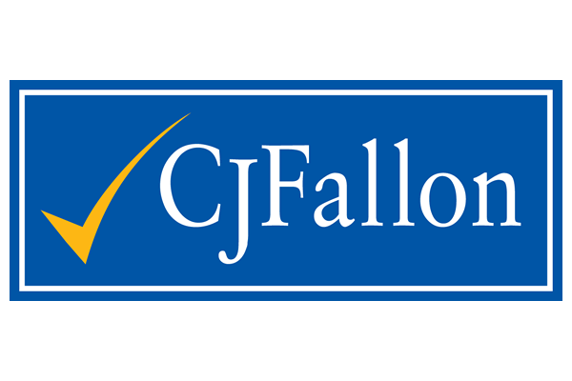

For access to CJ Fallon books please use the following link: cjfallonaccess
When you then click on a book to access for the first time you will have to enter your name, email and click parent. You can then continue as you wish.
- For English check out Away With Words for supplementary activities.
- Brain Teasers could be used for mental maths at the appropriate level.
- Mathemagic is our maths programme that we use. Figure It Out and Busy at Maths can also be used to supplement this. Master your Maths provides daily mental math questions.
- For Science, History and Geography check out Small World at the appropriate age group.
To navigate through the site, simple click Primary, the class rang, and the subject. This will the generate a list of appropriate resources. You can also use the search bar to look for something specific.
There are also some fantastic readers available on CJ Fallon. The first tile is fiction books and the Matter of fact version is non-fiction. All Rainbow readers are also available.
6th Class | Hello Universe!  Hello Universe! Matter of fact  My Read at Home 6
5th Class | Starry Links  Starry Links Matter of Fact  My Read at Home 5
4th Class | Blue Skies  Blue Skies Matter of Fact  My Read at Home 4
3rd Class | Bright Sparks  Bright Sparks! Matter of fact  My Read at Home 3
1st Class /2nd Class | Hitch up your roots and walk  Penny’s second book of facts  Jill’s new rollerblades  Busters second book of facts  The lost dog  The dinosaur egg  Penny’s first book of facts  The bouncing castle  Busters first book of facts  Here comes Buster!  My Read at Home 1/2
2nd Class | A surprise for Feena  GG’s new job  The treasure hunt  The magic ring  My Read at Home 2
Junior/Senior Infants | I see, I see  Hello!  Len likes to hide  Jen plays tricks  Look at this!  Visiting  Stories for you  A new baby

