COOSAN NATIONAL SCHOOL
HEALTHY EATING POLICY

As part of the Health Promoting Schools initiative and the Social, Personal and Health Education (S.P.H.E.) programme at Coosan National School we encourage our children to become more aware of the need for healthy food in their lunch boxes.

What people eat is known to be a key factor in influencing health. Research indicates a strong link between diet and performance (e.g. a low sugar intake promotes concentration, lessens hyperactivity, protects teeth and lessens the risk of diabetes. A low salt intake reduces the risk of heart disease in later life).
Children that have a healthy diet and drink enough water/fluid are able to concentrate and get the most from their lessons.
Dehydration is strongly linked to a decrease in concentration levels. It is important that children drink enough during the day, so that they don’t become dehydrated and tired. Drinks should always be included for break time and lunch. Water and milk are the most suitable drinks for children. Regularly drinking fizzy drinks, squashes (even the sugar-free ones) and fruit juices can erode the surface of the teeth. If you put fruit juice in your child’s lunch box, give them a straw, as drinking through a straw can help prevent dental erosion.

Aims:

- To promote the personal development and well-being of the child.
- To promote the health of the child and provide a foundation for healthy living in all its aspects.

Objectives:

- To enable each child to appreciate the importance of good nutrition for growing, developing and staying healthy.
- To enable each child to accept some personal responsibility for making wise food choices and adopting a healthy, balanced diet.

Lunch is an important meal for school-going children. It should provide one third of their recommended daily allowance of nutrients. To achieve this, foods should have a combination of low fat, low sugar and low salt content and should be high in fibre.

The traditional packed lunch of milk and sandwiches is under attack from a range of convenience foods like crisps, sweets, biscuits, chocolate and soft drinks. Parents and teachers are concerned about this trend and so it is incumbent on us all to come up with popular healthy alternatives. We ask you to encourage a healthy lunch right from the start.

The following guide is designed to help you provide quick, appetising, and nutritious lunches for your children:

Bread & Alternatives  Bread or rolls, preferably wholemeal  Rice – wholegrain  Pasta – wholegrain  Crackers/pitta bread – wholegrain  Wholemeal scones  Breadsticks  Potato salad | Protein Fillers  Lean Meat  Chicken  Turkey  Tinned Fish e.g. tuna/sardines  Cheese  Chickpea Spread e.g. Hummus.
Fruit & Vegetables  Apples - banana – Peach  Mandarins - Orange segments - Fruit Salad - Dried fruit - Plum - Pineapple cubes - Grapes - Cucumber - Sweet corn - Carrot – Peppers - mangetout - Tomato - Coleslaw. | Drinks  Water  Milk  Fruit juices  Yoghurt (1st – 6th classes only)

A word about Milk

Growing children should get approximately one pint of milk a day, or its equivalent as cheese, yoghurt or milk pudding. Low fat milk is fine for children from the age of two and low fat/skimmed milk is fine for children from the age of five onwards. This ensures that they get enough calcium, which is essential for healthy bones and teeth. If a child does not drink a glass of milk at lunch, encourage him/her to have a carton of yoghurt (1st – 6 classes only) or a small helping of cheese instead.

We ask that children do not bring the following to school:

These snacks are mostly high in sugar, saturated fat and salt and have little nutritional goodness in them; they are not essential for health and taken in excess can be harmful.

- Crisps (including crisp-style snacks)
- Fizzy drinks (including fizzy fruit-flavoured water, juices, etc)
- Sweets
- Chocolate biscuits/bars
- Chewing gum
- Fruit winders
- Popcorn.

To support healthy lunch provision, teachers will reward children from time to time who do their utmost to have fruit and vegetables and other healthy foods in their lunchboxes.

A very simple approach to healthy eating is to use the Food Pyramid:
The Department of Health has recently launched a new Food Pyramid and guidance materials to help people make choices to maintain a healthy, balanced diet. This guidance applies for everyone from 5 years of age upwards. The three key messages are:
- Limit high fat, sugar and salt foods from the top shelf of the Pyramid to no more than once or twice a week.
- Eat more fruit and vegetables, at least 5 to 7 servings a day.
- Use the Pyramid as a guide for serving sizes and remember that portion size matters.
The new Food Pyramid and further information can be found at www.healthyireland.ie under the Healthy Eating Guidelines tab http://www.healthyireland.ie/health-initiatives/heg/

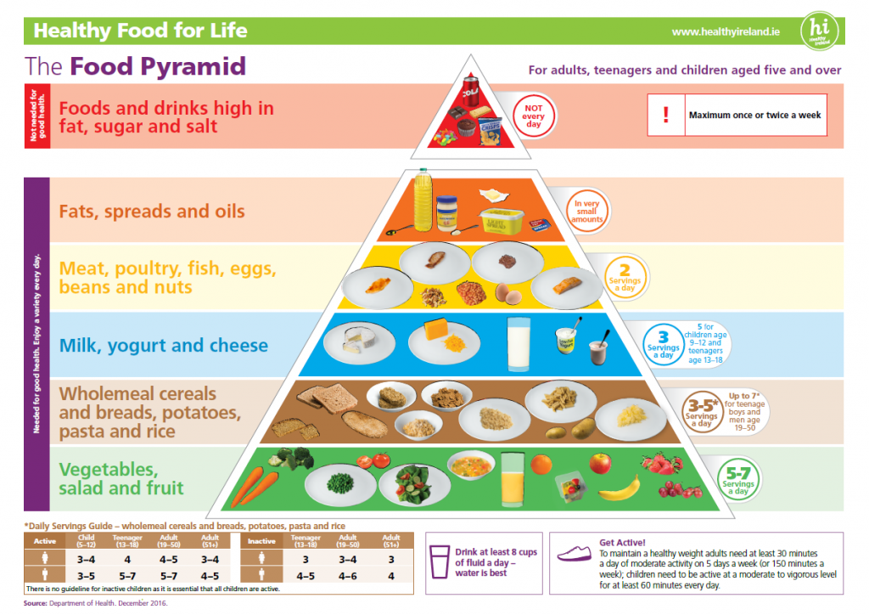
Green Flag School

Our green school motto is:
‘REDUCE REUSE RECYCLE!’

With this in mind, children are also asked to:

- Take home (in lunchbox) all uneaten food, silver paper, wrappings, containers and cartons.
- Put fruit peel only into the compost bins.
- Refrain from bringing in cans and glass – (for safety reasons).

N.B. Parent(s)/guardian(s) of any child with a medical condition which requires a special diet should contact the school.

This policy was ratified by the staff on

This policy was ratified by the Board of Management on

This policy was ratified by the Parents’ Association on

